**1.** Check the current working directory command, then get a list of all files & folders including hidden file as well as file-size of each file and folder.

Ans – pwd , ls -la

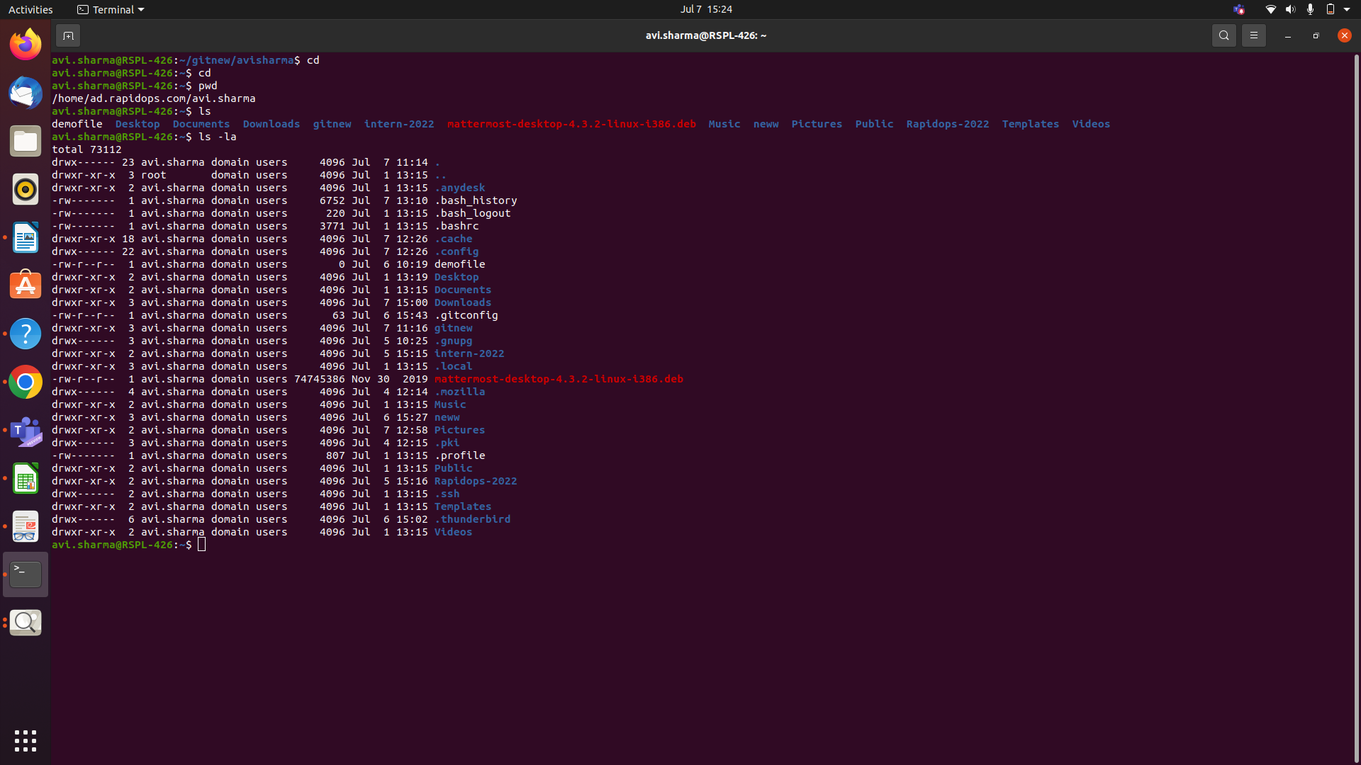

**2.** Then create two folders named as **'intern-2021'** & **'rapidops-2021'**,

Ans2) mkdir

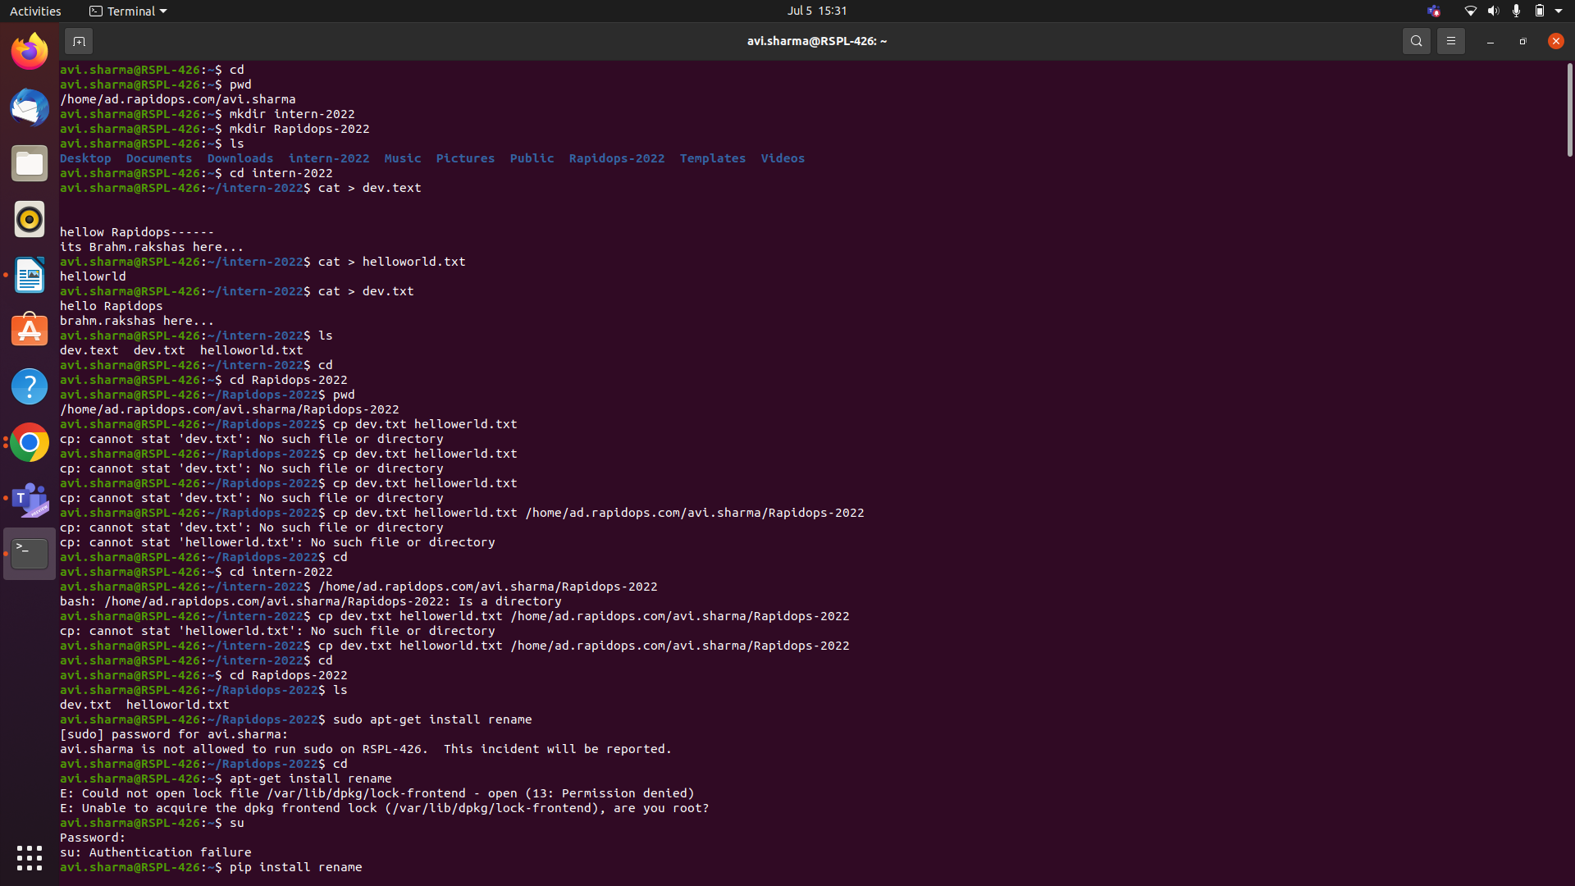

**3.** Then create two files within **'intern-2021'** folder, names are **'dev.txt'** & **'helloworld.txt',**

**Ans3) cat or touch**



**4.** Then open the **'dev.txt**' file and write something in it, and in **'helloworld.txt'** file write **'helloworld'** using echo command

Ans ) echo ‘text’ > file name

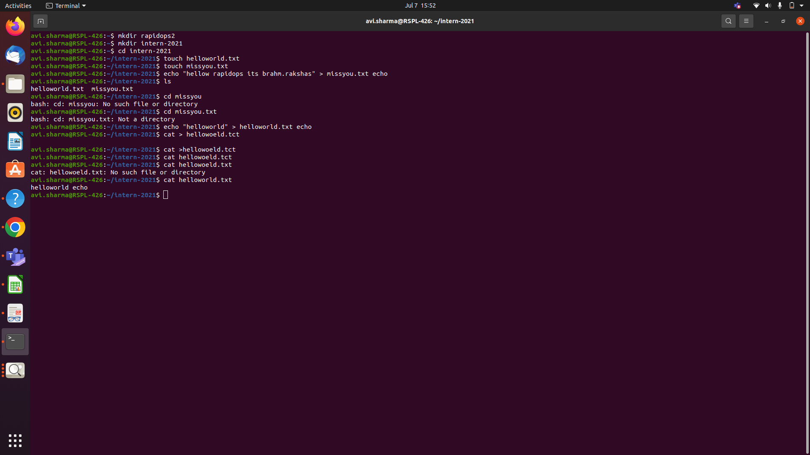

**5.** Now copy 'dev.txt' and 'helloworld.txt' into **rapidops-2021** folder,



**6.** Now go to the **rapidops-2021** folder and rename those two (dev.txt, helloworld.txt) files.

Ans6) mv

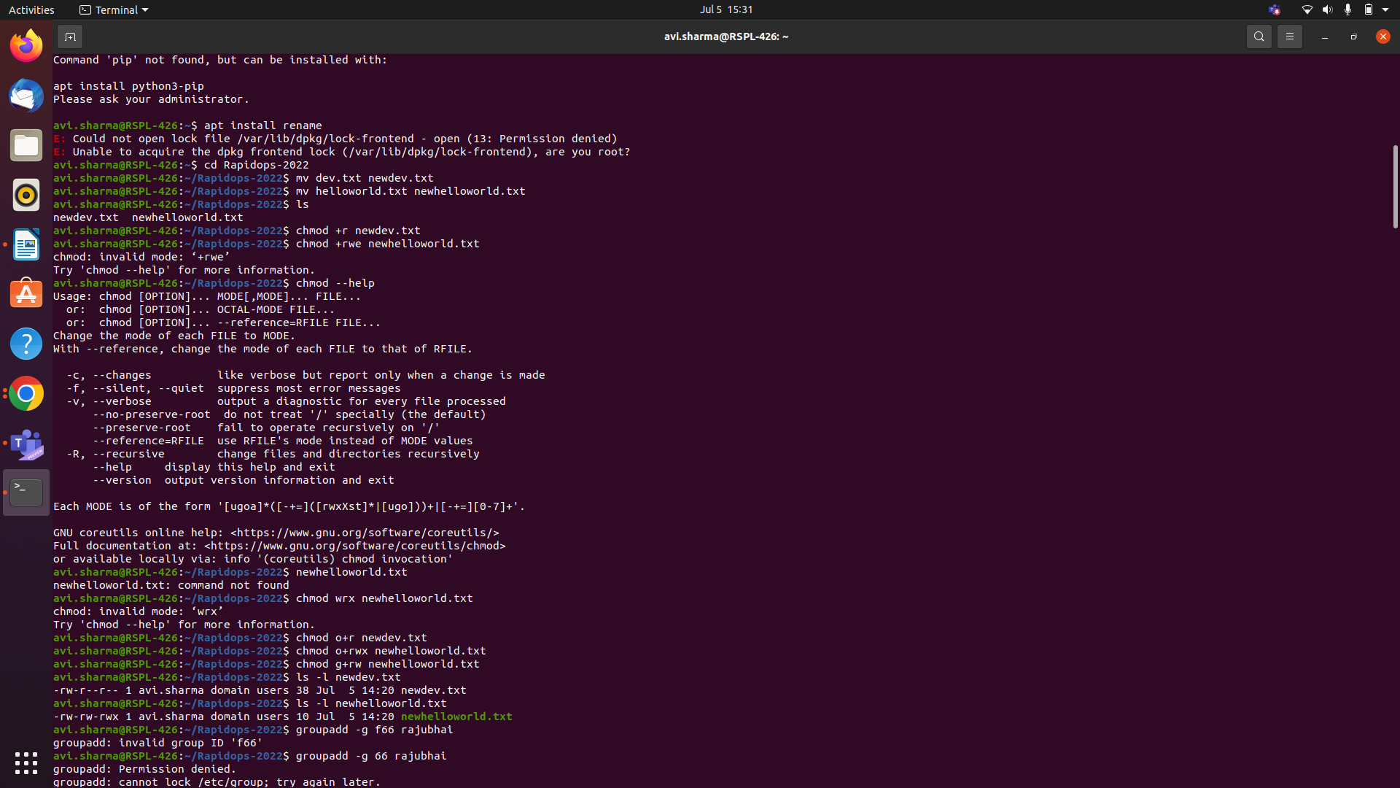

**7.** In the same directory path, give 'read only' permission to **dev.txt** for file’s owner, and for **helloworld.txt** give 'read-write-execute' permission to it's owner & 'read-write' permission to it's group.

Ans7) chmod



**8.** Now create archive file within same directory and shift into **intern-2021** directory.

9. Now copy that archive file in this directory location and remove that older archive  
file.

Ans8) tar

Ans9) tar cf and rm tar

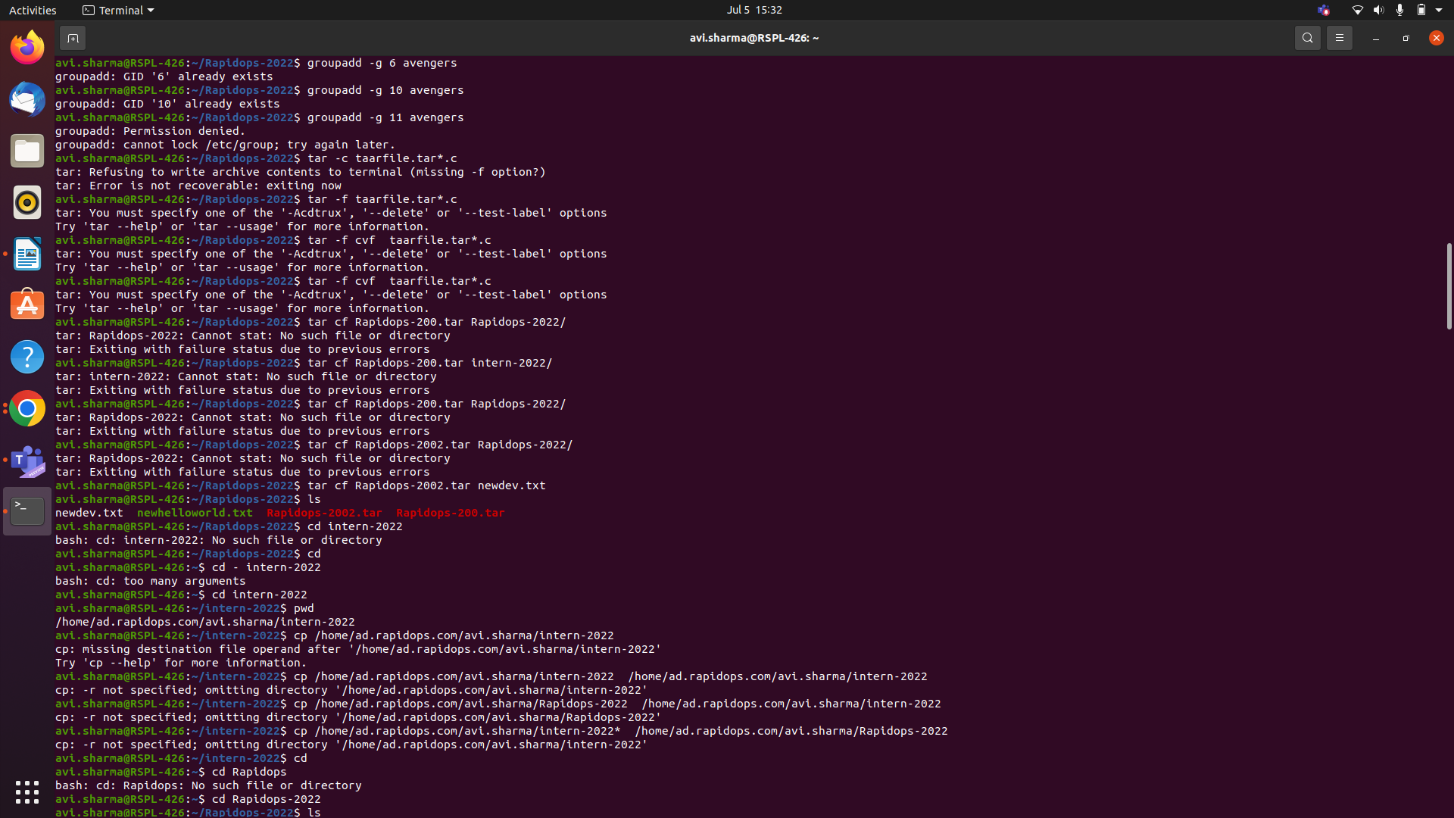

**10.** Using the command find out the **dev.txt** file.

Ans10 ) find

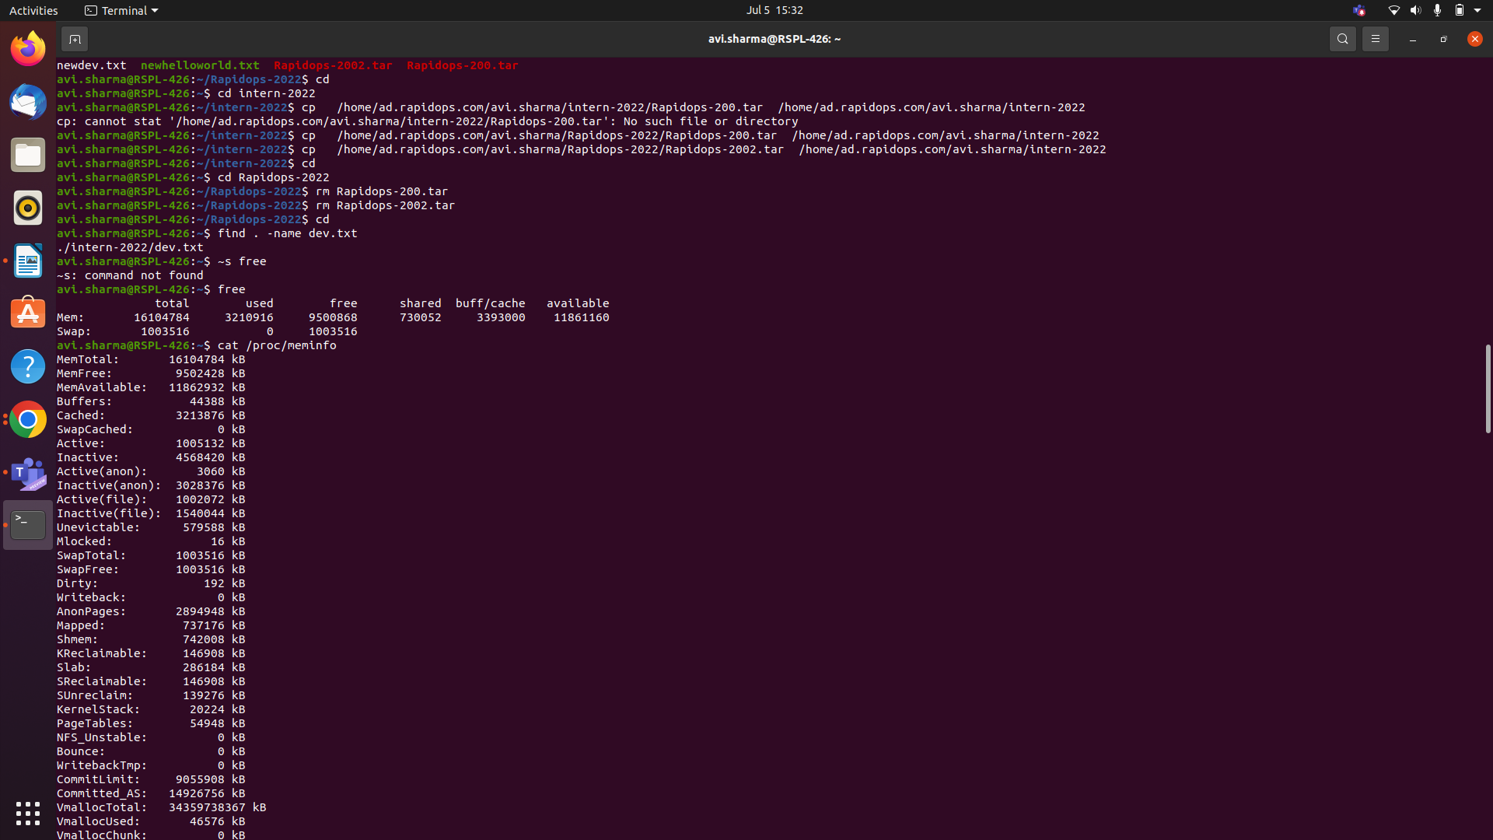

**11.** Check the CPU, memory usage using CLI.

**12.** Check the disk usage and free disk space using CLI.

Ans11 , 12) free , $ cat /proc/meminfo



**13.** Check the all system process and filter out any of one process service using CLI.

Ans13)

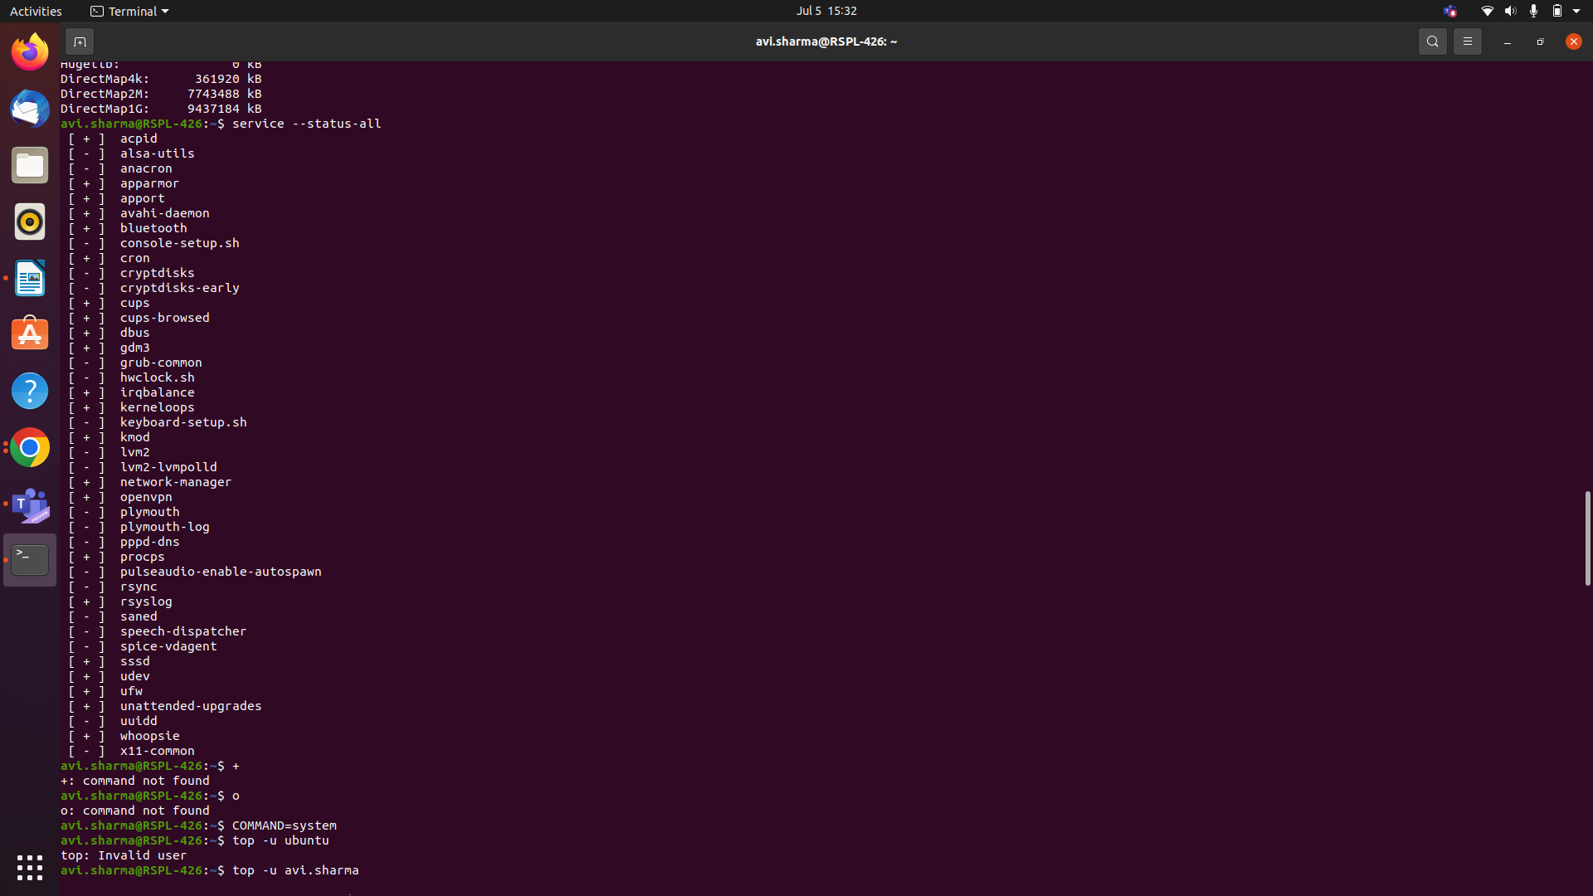

**14.** Retrieve the content from web server using CLI.

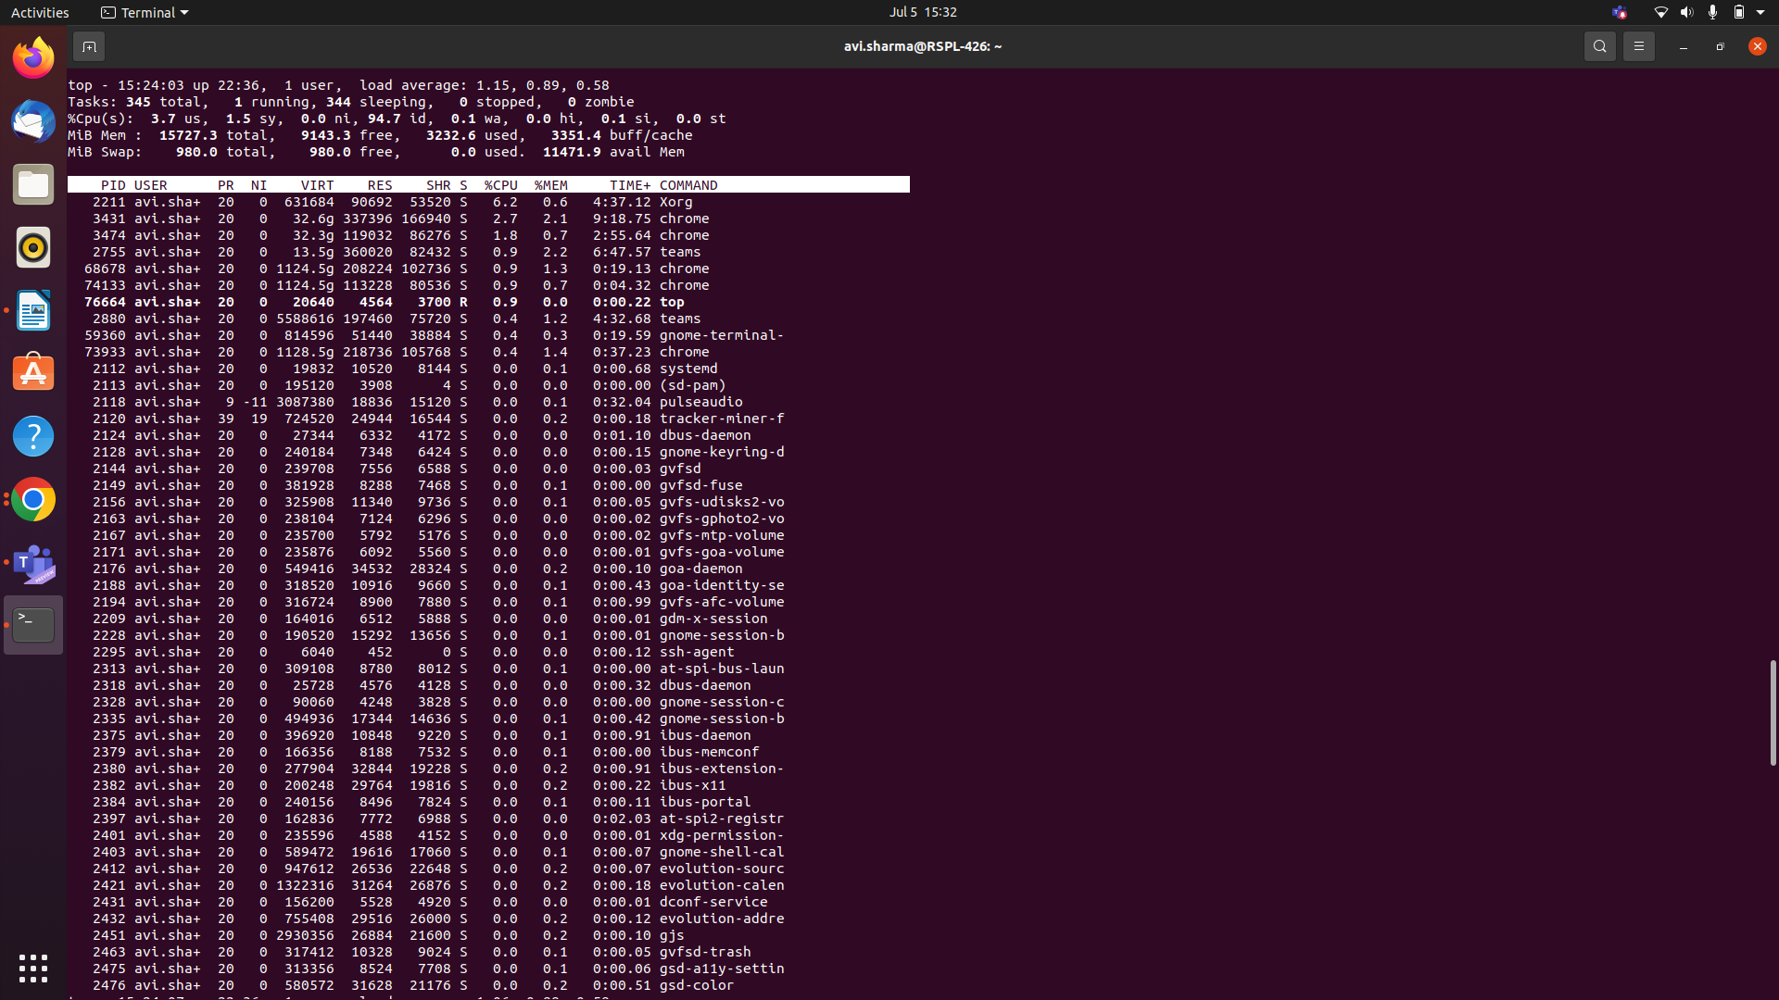

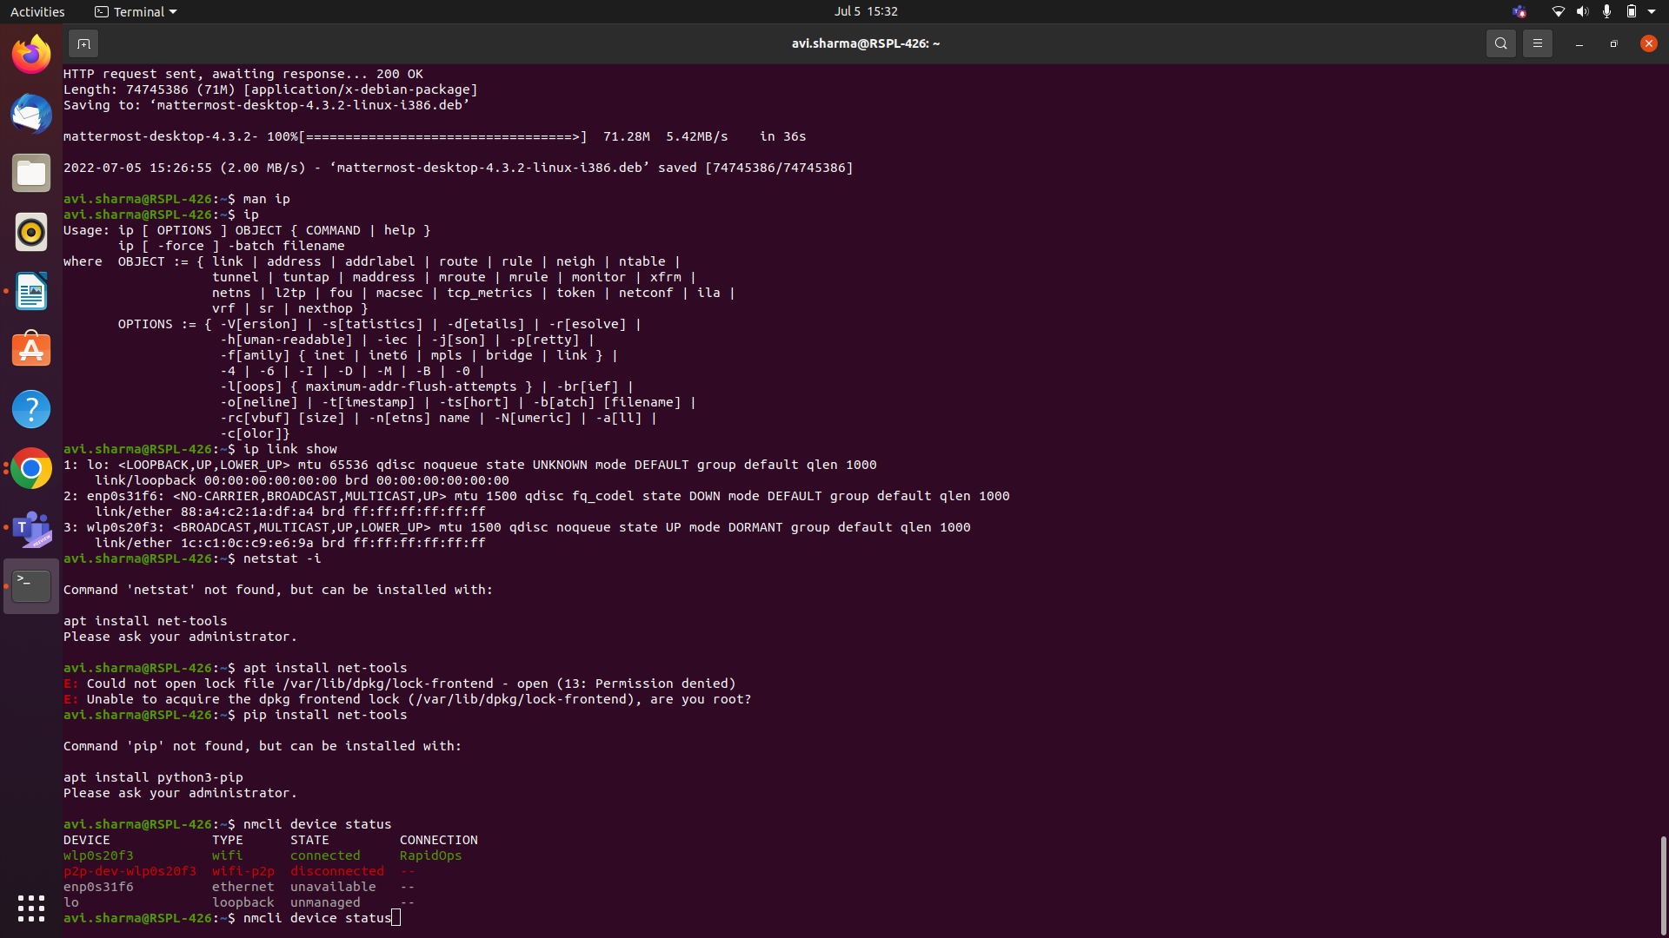

**15.** Check your network interface information using CLI.

Ans15) ip link show

